**Packet Capture using Wireshark:**

1. Click on the ‘loopback’ interface and start capturing the packets.Depending upon the type of packets to be captured, apply the filter related to the selected protocol. Here, we are obtaining UDP packets.

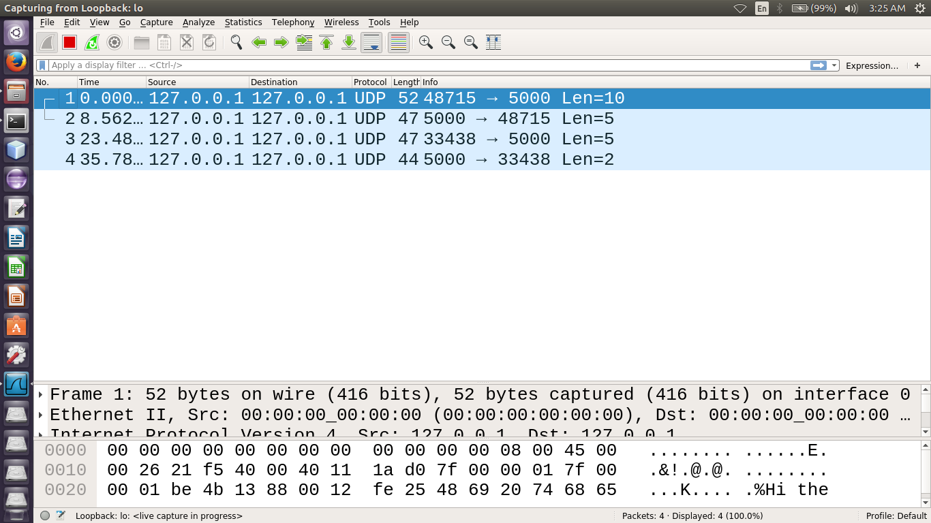

1. In the next step,analyse the packet by clicking on it.We can understand the version of IP being used, source port, destination port being used,etc.Also we can know the size of the frame, source address, destination address being used.(IPv4 in this case and type of protocol being UDP)

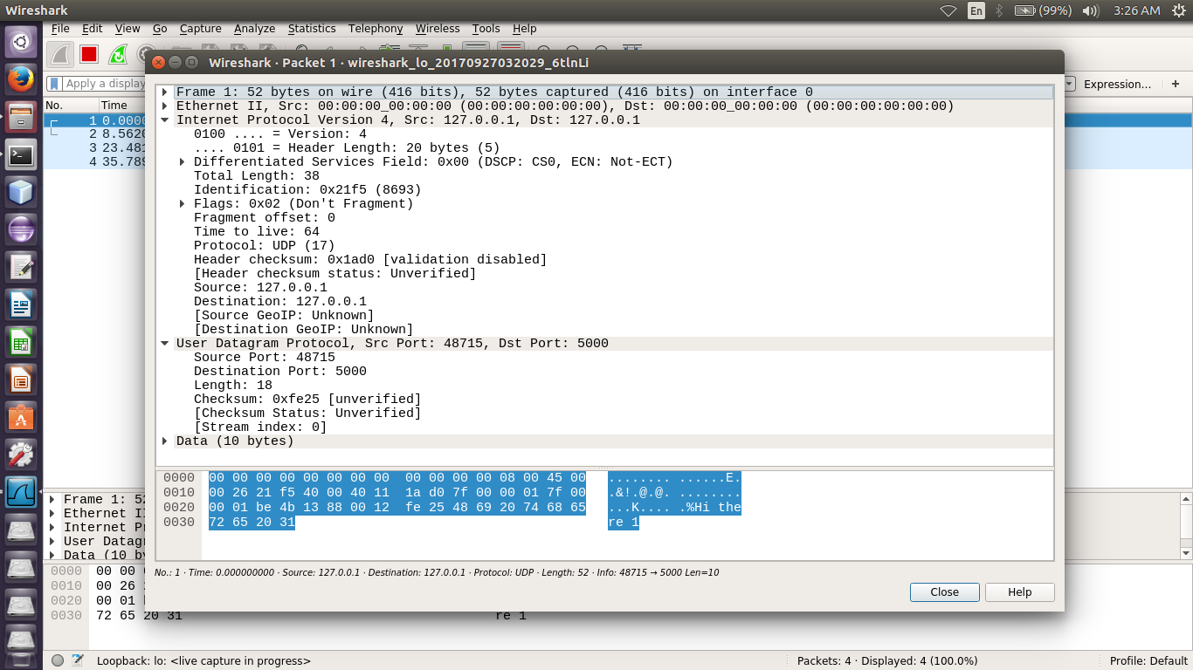

1. **IO Graph:** IO Graph helps us to understand the packet flow better. By applying filters we can analyze the success rate or failure rate for transmission of a certain type of packets. In this case, the graph shows information about all packets as well as errors in TCP packets.

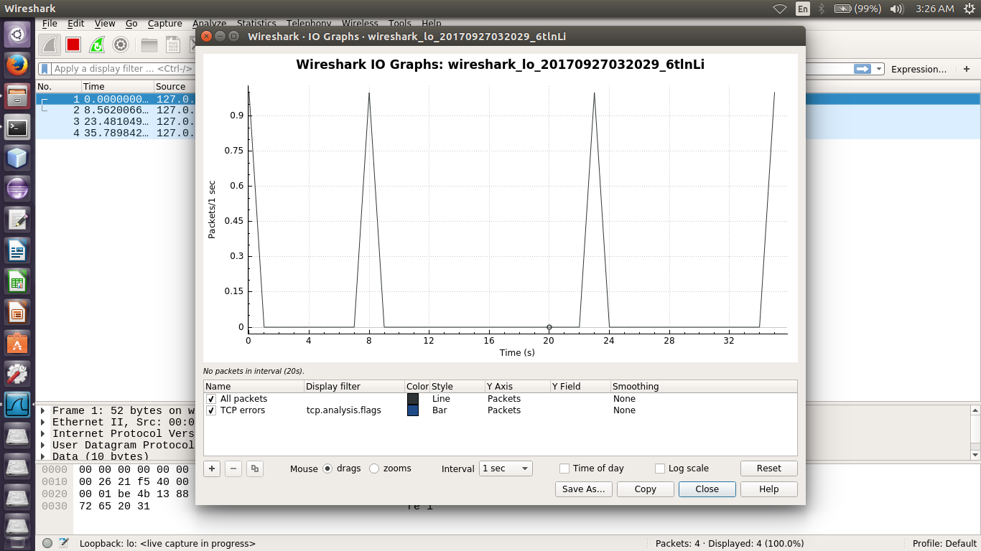

1. **Flow Graph:** Flow graph shows the timing diagrams for transmission of various types of packets. Here, we are analyzing the UDP packets sent.

